Designing a Network Infrastructure for a College Campus

A

Project Report

submitted

­­­­­­­

In Partial fulfillment of the requirements for award of the degree of

Bachelor of Science

in

Computer Science

SUBMITTED BY

S.Siranjivipandi

(Register No: 2­­­­­­­0SUCS029)

Under the guidance of

Mr. M. Selvakumar, M.Sc., M. Phil.,

Assistant Professor



Department of Computer Science

MANNAR THIRUMALAI NAICKER COLLEGE(Autonomous)

Pasumalai , Madurai-4.

April-2023

MANNAR THIRUMALAI NAICKER COLLEGE(AUTONOMOUS)

PASUMALAI, MADURAI-625 004.



BONAFIDE CERTIFICATE

This is to certificate that this project work entitled “Designing a Network Infrastructure for a College Campus” Bonafide record work done by S.Siranjivipandi (Register No:20SUCS029) in partial fulfillment for the award of the degree of B.Sc (Computer Science) of MANNAR THIRUMALAI NAICKER COLLEGE(Autonomous).

Submitted for the project evaluation and viva voce held on ………………...

Internal Guide HOD

Mr. M. Selvakumar, M.Sc., M. Phil., Dr. G.Devika,M.C.A.,M.Phil.,P.hD.,

EXTERNAL EXAMINER

DECLARATION

I hereby declare that this software project done under the title “Designing a Network Infrastructure for a College Campus” is submitted for the award of B.Sc. (Computer Science) is the original work and that no part of this project has been submitted fully or partially for any other reorganization earlier.

Date : SIGNATURE

Place : MADURAI (S.Siranjivipandi)

ACKNOWLEDGEMENT

I thank our almighty for having showered his blessings upon us carry out this project word successfully.

I would not have been possible this project without the support from our parents and friends. Works are inadequate to thank them. Our parents are having been great and they are offering good guidance and support to us.

That is we pleasant duty to thank our principal Dr. B. Manoharan, M.Com., M.Phil., MBA., MCA., B.Ed., PGDCA., PGDCM., Ph.D. *Principal,*  Mannar Thirumalai Naicker College, Madurai for allowing me to do this project.

I express my sense of gratitude and heartfelt thanks to Mr.C.Prabhu, Director i/c (SF), Assistant Professor, Mannar Thirumalai Naicker College.

I take this opportunity to express our thanks to Dr. G.Devika,M.C.A.,M.Phil.,P.hD., Head of the Department of Computer Science, MannarThirumalaiNaicker College.

I expressour sincere thanks to my class in charge and my guide Mr. M. Selvakumar, M.Sc., M. Phil., Assistant Professor of Computer Science, Mannar Thirumalai Naicker College for her valuable guidance.

I would like to acknowledge kind help and whole hearted co-operation extended to me by the staff members of our department.

My hearty thanks one and all who helped us in the successful completion of this project.

|  |  |  |
| --- | --- | --- |
| S.No | Contents | Page No |
| 1 | Introduction |  |
| 1.1 | Abstract |  |
| 2 | System Analysis |  |
| 2.1 | Existing System |  |
| 2.2 | Proposed System |  |
| 3 | System Requirement Specification |  |
| 3.1 | Hardware Specification |  |
| 3.2 | Software Specification |  |
| 3.3 | Network Requirements |  |
| 4 | Network Devices |  |
| 5 | Protocols |  |
| 5.1 | File Transfer Protocol (FTP) |  |
| 5.2 | Dynamic Host Configuration Protocol (DHCP) |  |
| 5.3 | Open Shortest Path First (OSPF) |  |
| 6 | Server |  |
| 6.1 | Mail Server |  |
| 6.2 | FTP Server |  |
| 6.3 | DHCP Server |  |
| 7 | IP Address Planning |  |
| 8 | Flow Diagram |  |
| 9 | Coding |  |
| 10 | Screenshots |  |
| 11 | Testing |  |
| 12 | Future Enhancement |  |
| 13 | Conclusion |  |
| 14 | Bibliography |  |

­­­­­

1. INTRODUCTION
   1. ABSTRACT

In today's world, Networking have become extremely necessary for providing communication, security, chat and others services. In these services, computer networks play very important role to communicate, administrate, automate and process the information from point to another points. In this project Cisco pocket tracer is used as a network simulator tools to simulate and Design a network project for a College. The project discusses interconnection between routers, switches and other components in data communication network and how are programmed and configured. Smart office and Server Room uses IoT technology to automate different activities of office and Labs. IoT devices connected to the internet, to allow the distant monitoring and controlling of different appliances such as light, fan, air conditioner, etc. In this project, I implemented smart office using new released “Cisco packet tracer” simulation software, since different IOT device used for automation is included in this new version simulator. The previous software has only networking device, but in new released simulator IOT device is included those are sensor, board, IOE device and Programming Languages with classically networking device. To design smart office I used different device used for security, safety and environment prosperity. The protocols used for designing a Network Infrastructure are RIP, DHCP, VLAN, OSPF, MAIL, FTP, HTTP, A College campus consists of multiple labs, Net cafe, departments and server rooms.

2. SYSTEM ANALYSIS

###### **INTRODUCTION**

System Analysis and Design, is the process of gathering and interpreting facts, diagnosing problem and using the information to recommend improvement to the system.  Before development of any project can be pursued, a system study is conducted to learn the details of the current business solution.  Information gathered through the study forms the basis for creating alternative design strategies.  Virtually all organizations are systems that interact with their environment through receiving input and producing output.

It is a management technique used in designing a new system, improving an existing system or solving problem.  System analysis does not guarantee that the user will derive an ideal solution to a problem.  This depends solely on the way one design a system to exploit the potential in the method.  To put it in another way, creativity is as much as must pre-design the study and problem solving process and evaluate every successive step in the system analysis.

Taking all these factors into account and with the knowledge of the inter-relationship between the various fields and section and their potential interactions, they are consider for developing the whole system in and integrated manner, this project is developed to meet all the criteria in the management technique is also helps us in develop and design of the new system or to improve the existing system.

2.1. EXISTING SYSTEM

All the hosts are assigned with static IPs and are assigned in the order in which it where set up. No support for dynamic IP allocations. Even though the working is divided into three major sectors all the host, multimedia devices are connected in a single network. Thus, network security and maintenance are difficult. One more problem observed was the existing switches were outdated and hence could not prove to be beneficial for the network administrator to observe monitor and handle the network traffic the system has no remote access to the network. Absence of basic small-scale businesses firewall was also observed. Thus, security is also compromised. Three server rooms were used for the purpose of independent networking which further caused wastage of power and money

2.2. PROPOSED SYSTEM

In order to implement Smart Campus used new released Cisco packet tracer, which included different smart object used for home automation such as smart fan, smart window, smart door, smart light, smart Window, smart door, fire sprinkler, lawn sprinkler and different sensor is included. To control this smart object and sensor, microcontroller (MCU-PT) and Home Gateway used, since it provide programming environment for controlling smart object connected to it and provide controlling mechanisms by registering smart device to Home Gateway respectively . In the proposed System Protocol Switch Routing Information Protocol (RIP) to Open Shortest Path First. It is a widely used and supported routing protocol. It is a more intelligent routing protocol than RIP, IGRP and EIGRP. It supports unlimited router in the network, It is basically use for larger size organization in the network

3. SYSTEM REQUIREMENT SPECIFICATION

3.1. HARDWARE SPECIFICATION

The above Hardware specifications were used in both Server and Client machines when developing

.

* System : Ryzen 7 4800H.
* Hard Disk : 512 GB
* Monitor : FHD 144Hz
* Mouse : Logitech.
* Ram : 16 GB.

3.2. SOFTWARE SPECIFICATION

SOFTWARE NAME: Cisco Packet Tracer

* + In this project Cisco pocket tracer is used as a network simulator tools to simulate and Design a network project for a College.
  + Cisco Packet Tracer as the name suggests, is a tool built by Cisco. This tool provides a network simulation to practice simple and complex networks.
  + The main purpose of Cisco Packet Tracer is to help students learn the principles of networking with hands-on experience as well as develop Cisco technology specific skills. Since the protocols are implemented in software only method, this tool cannot replace the hardware Routers or Switches. Interestingly, this tool does not only include Cisco products but also many more networking devices.

3.3. NETWORK REQUIREMENTS

1: The new system should be able to reduce internet downtime. Download and upload links should be maintained above 5 Mbps speed requirement.

2: Network will be scalable.

3: The system should support remote access.

4: Should comprise of data centres with necessary security features and support.

4. NETWORK DEVICES

## **Cisco Router 4331**

* Wire-speed performance for concurrent services such as security and voice, and advanced services to multiple T1/E1/DSL WAN rates
* Enhanced investment protection through increased performance and modularity
* Enhanced investment protection through increased modularity
* Increased density through High-Speed WAN Interface Card Slots (four)
* Enhanced Network Module Slot
* Support for over 90 existing and new modules ✓ Support for majority of existing AIMs, NMS, WICS, VWICS, and VICS
* Two Integrated 10/100 Fast Ethernet ports ✓ Optional Layer 2 switching support with Power over Ethernet (PoE) (as an option) Security
* On-board encryption
* Support of up to 1500 VPN tunnels with the AIM-EPII-PLUS Module
* Antivirus defence support through Network Admission Control (NAC)
* Intrusion Prevention as well as stateful Cisco IOS Firewall support and many more essential security features

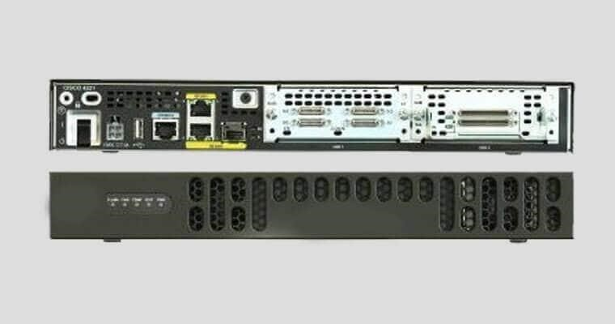

Cisco switch 2960-24TT

* Cisco Catalyst 2960 Series switches support voice, video, data, and highly secure access. They also deliver scalable management as your business needs change.
* The Common Features are included: Enhanced security including Cisco Trust Sec for providing authentication, access control, and security policy administration, Multiple Fast or Gigabit Ethernet performance options.
* Cisco Energy Wise for power management, Scalable network management.
* Cisco Catalyst 2960 Series Switches have using Auto Smart Ports, installation with Auto Install and enhanced troubleshooting to facilitate ease of use.
* Comprehensive management tools such as Cisco Network Assistant provide ongoing management and monitoring of switches
* Price: 1,58,869/-

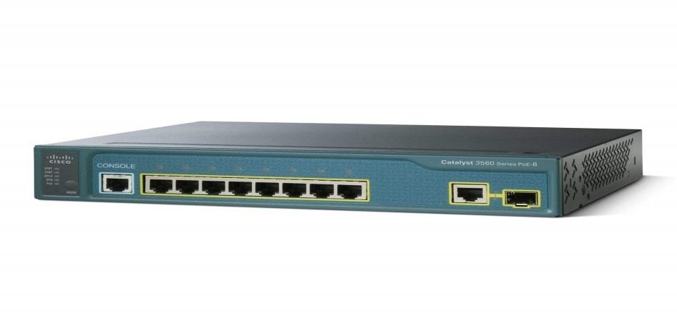

Server

* A server is a computer that provides data to other computers. May serve data to systems on a local area network (LAN) or a wide area network (WAN) over the Internet.

* While any computer can be configured as a server, most large businesses use rack-mountable hardware designed specifically for server functionality. In a business or corporate environment, a server and other network equipment are often stored in a closet or glass house.

* When a client requires data or functionality from a server, it sends a request over the network. The server receives this request and responds with the appropriate information.

* There are many types of servers that all perform different functions. File server. Print server, Web server, Database server, proxy server, Ftp server, Blade server, Virtual server, Telnet server etc…

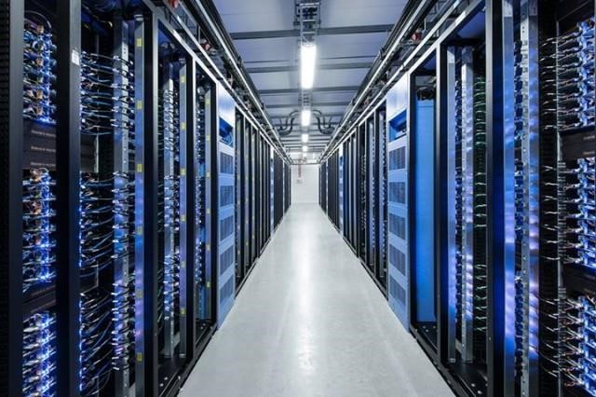

Personal Computer

* A computer is a device that accepts information and manipulates it for some result based on a program, software, or sequence of instructions on how the data is to be processed.
* The second type of computer you may be familiar with is a laptop computer, commonly called a laptop. Laptops are battery-powered computers that are more portable than desktops, allowing you to use them almost anywhere

* The best business computers still have an important role to play in any modern office.

* 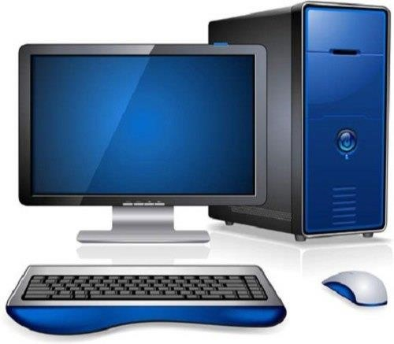

Computer Maintenance Plans

* Anti-virus software checkups
* Disk space utilization
* Defragmentation of hard drives
* Troubleshoot hardware and software issues
* Temporary internet files purging
* Installed software checkups

Laptop

* A laptop computer is a small personal computer. They are designed to be more portable than traditional desktop computers, with many of the same abilities. Laptops are able to be folded flat for transportation and have a built-in keyboard and touchpad.

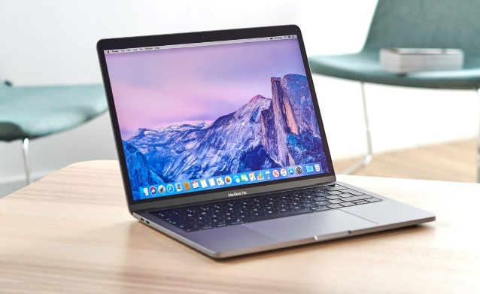

* Most laptops are powerful enough for everyday business administrative, home, or school use. However, if a user does graphical work such as 3D rendering or movie encoding.
* Similar to personal computers, laptops require a power source—they can be plugged into an outlet or operate on their internal battery. Laptop computers can be used at a desk by themselves, or as a desktop-style computer by connecting a separate monitor, keyboard, and mouse.
* These small computers can also be hooked into docking stations—devices that allow some laptops to easily connect to peripherals like monitors and keyboards at a desk—and then "undock" for easy mobile use and transport.
* Components such as processors, motherboards, memory sticks, hard drives, graphics cards, and interface devices are all items that form a laptop computer. The smaller these components are, the smaller and lighter a laptop can be.

Firewall

* A firewall is a network security device that monitors incoming and outgoing network traffic and decides whether to allow or block specific traffic based on a defined set of security rules.
* Firewalls have been a first line of defense in network security for over 25 years. They establish a barrier between secured and controlled internal networks that can be trusted and untrusted outside networks, such as the Internet.
* A firewall can be hardware, software, software-as-a service (SaaS), public cloud, or private cloud (virtual).

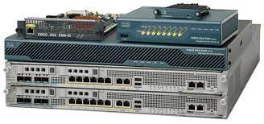

* Firewalls carefully analyze incoming traffic based on pre-established rules and filter traffic coming from unsecured or suspicious sources to prevent attacks.
* Firewalls guard traffic at a computer’s entry point, called ports, which is where information is exchanged with external devices.

IoT GATEWAY

* An IoT Gateway is a solution for enabling IoT communication, usually device -to-device communications or device-to-cloud communications. The gateway is typically a hardware device housing application software that performs essential tasks. At its most basic level, the gateway facilitates the connections between different data sources and destinations.
* A simple way to conceive of an IoT Gateway is to compare it to your home or office network router or gateway. Such a gateway facilitates communication between your devices, maintains security and provides an admin interface where you can perform basic functions

IoT Gateway feature set:

* + Facilitating communication with legacy or non-internet connected devices
  + Data caching, buffering and streaming
  + Device to Device communications/M2M
  + Networking features and hosting live data
  + Data visualization and basic data analytics via IoT Gateway applications
  + Security – manage user access and network security features
  + Device configuration management
  + System diagnostics

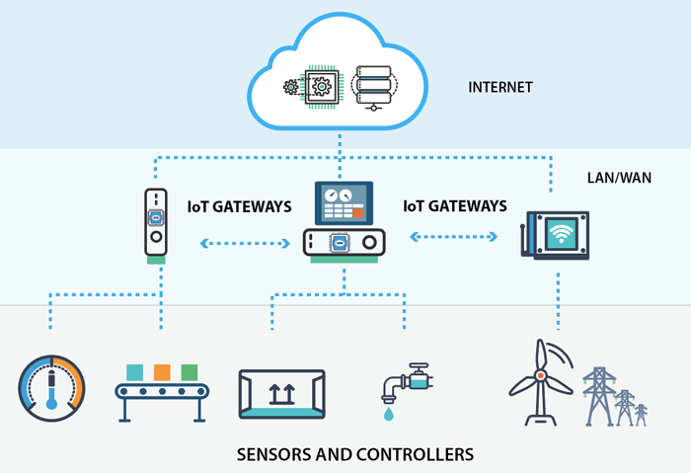

CABLE

Serial cable DCE

* Serial cable (DCE) stands for Data Communications Equipment DCE is typically a modem, DSU/CSU, or other piece of data communications equipment.
* A Cisco serial interface is operating as a DTE by default.
* When you take a cable and connect two routers directly by their serial interfaces (with a DTE/DCE), they are both waiting for the other to send them a clock rate. One of the interfaces must act as the DCE and that interface must send the clock rate.
* In a data station, the equipment that performs functions, such as signal conversion and coding, at the network end of the line between the data terminal equipment (DTE) and the line, and that may be a separate or an integral part of the DTE or of intermediate equipment.

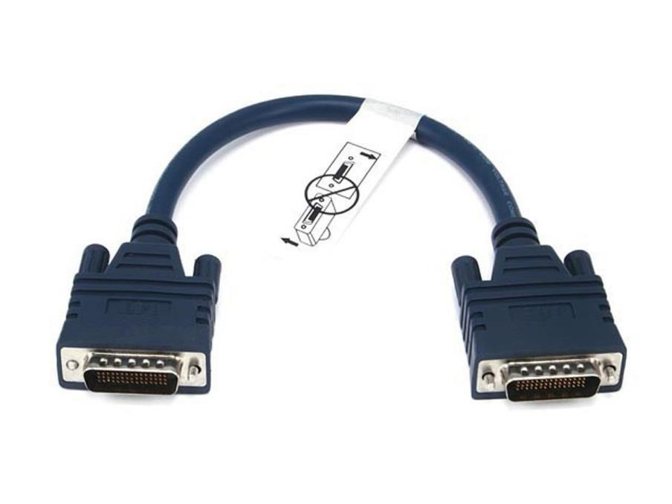

Straight through (RJ-45)

* Straight-through cable is used to connect computers and networking devices such as hubs and switches
* Straight-through cable is also commonly referred to as patch cable.
* Straight cable looks like Both sides (side A and side B) of cable have wire arrangement with same color
* Straight-through cable is a type of CAT5 with RJ-45 connectors at each end, and each has the same pin out in accordance with either the T568A or T568B standards.
* It uses the same color code throughout the LAN for consistency and is used in LAN to connect a computer or a network hub such as a router

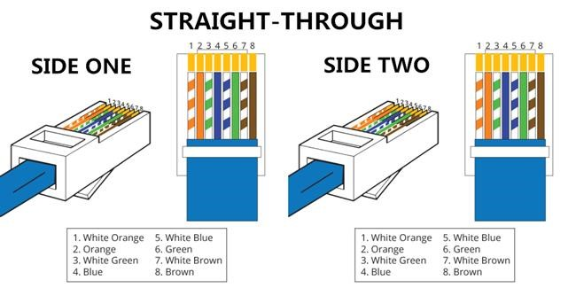

Gigabit Ethernet RJ45

* The latest series of Ethernet standards covers networks that can transfer data at more than a thousand million bits per second.
* The gigabit LAN RJ45 is the common name for connecting the network cable to the computer. Newer, faster Ethernet standards are called "Gigabit."
* Gigabit Ethernet cables combine industry-leading, high-speed performance with significant size and weight advantages over comparable cables.
* Their durable design and exceptional electrical and mechanical performance characteristics make them ideal for a broad range of high-speed Ethernet applications in the aerospace, defense, military, ground transportation, industrial and RF communication markets.
* Gigabit Ethernet cables have been developed in a wide variety of configurations to provide 1 and 10 Gb performance in the most demanding applications.

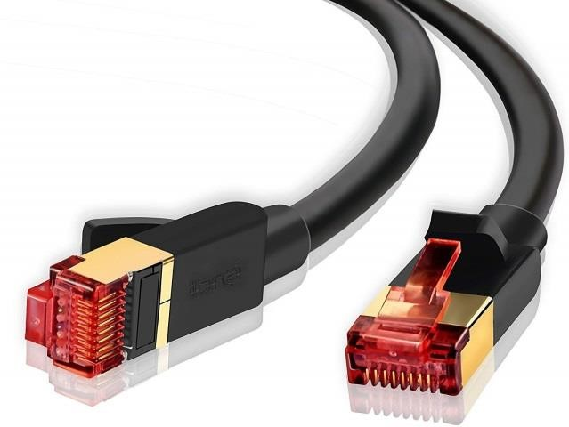

ROUTING PROTOCOL

Routing Information Protocol (RIP)

* Routing Information Protocol (RIP) is a distance-vector routing protocol.
* Routers running the distance-vector protocol send all or a portion of their routing tables in routing-update messages to their neighbours.
* You can use RIP to configure the hosts as part of a RIP network.
* RIP uses the User Datagram Protocol (UDP) as its transport protocol, and is assigned the reserved port number 520.
* HOW DOES ROUTER RIP WORK?
* RIP protocol periodically reads the routing table and shares it with neighbours through a broadcast message. Upon receiving a broadcast message from a neighbour, the RIP protocol reads the broadcast message and updates the routing table accordingly.

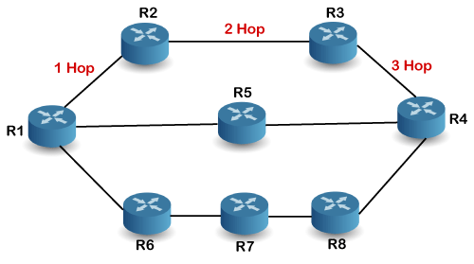

VERSIONS OF RIP

* There are three standardized versions of the Routing Information Protocol:
  + RIPv1
  + RIPv2 for IPv4
  + RIPng for IPv6.

RIPv1

* RIP v1 is an older, no longer much used routing protocol.

RIPv2

* + RIP v2 is a classless protocol and it supports class full, variable-length subnet masking (VLSM), CIDR, and route summarization.
  + RIPv2 supports authentication of RIPv2 update messages (MD5 or plain-text).

RIPng

* + The Routing Information Protocol next generation (RIPng) is an interior gateway protocol (IGP) that uses a distance-vector algorithm to determine the best route to a destination, using hop count as the metric.
  + RIPng is an extension of RIP developed for support of IPv6.

DHCP SERVER

* Dynamic host configuration protocol that automatically provides an ip address and other related configuration information such as subnet mask and default gateway.
* DHCP allows host to obtain required TCP/IP configuration information from DHCP server.
* DHCP minimizes configuration errors caused by manual IP address configuration. Such as typographical error or address conflicts caused by the assignment of an IP address to more than one computer at the same time
* One of the key vulnerabilities of DHCP has been the use of so-called man in the middle (MITM) attacks.
* Which the attacker secretly intercepts and relays message between two parties who believe they are communicating directly with each other.
* DHCP relay agent is any TCP/IP host which is used to forward request and replies between DHCP server and client when the server is present on the different network. Relay agent receive DHCP message and the Generate a new DHCP message to send out on another INTERFACE.

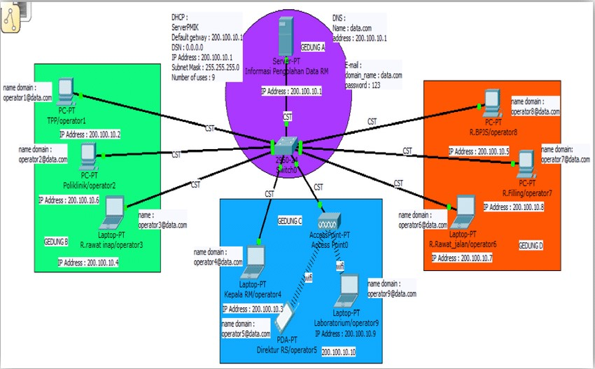

VLAN

* VLAN is a custom network which is created from one or more local area networks. It enables a group of devices available in multiple networks to be
* Combined into one logical network. The result becomes a virtual LAN that is administered like a physical LAN. The full form of VLAN is defined as Virtual Local Area Network.

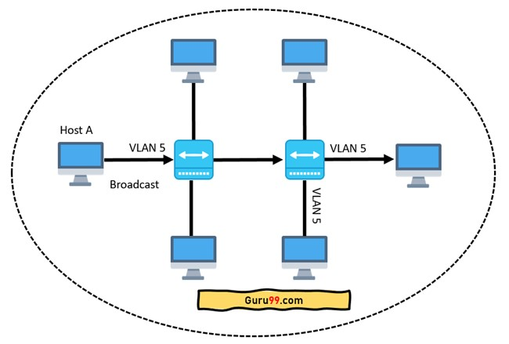

* Here is step by step details of how VLAN works:
* VLANs in networking are identified by a number.
* A Valid range is 1-4094. On a VLAN switch, you assign ports with the proper VLAN number.
* The switch then allows data which needs to be sent between various ports having the same VLAN.
* Since almost all networks are larger than a single switch, there should be a way to send traffic between two switches.
* One simple and easy way to do this is to assign a port on each network switch with a VLAN and run a cable between them.

Open Shortest Path First (OSPF)

* Open Shortest Path First (OSPF) is a link-state routing protocol that was developed for IP networks and is based on the Shortest Path First (SPF) algorithm. OSPF is an Interior Gateway Protocol (IGP).
* In an OSPF network, routers or systems within the same area maintain an identical link-state database that describes the topology of the area.
* Each router or system in the area generates its link-state database from the link-state advertisements (LSAs) that it receives from all the other routers or systems in the same area and the LSAs that itself generates.
* An LSA is a packet that contains information about neighbors and path costs. Based on the link-state database, each router or system calculates a shortest-path spanning tree, with itself as the root, using the SPF algorithm.

Open shortest path first (OSPF) router roles and configuration -  GeeksforGeeks

OSPF has the following key advantages:

* + Both IPv4 and IPv6 routed protocols
  + Load balancing with equal-cost routes for the same destination
  + VLSM and route summarization
  + Unlimited hop counts
  + Trigger updates for fast convergence

MAIL SERVER

* Mail Server is a computer that helps move email messages along to their intended destinations.
* Mail servers show into two main categories: outgoing mail servers and incoming mail server.
* Outgoing mail servers are known as SMTP, and Incoming mail servers come in POP3, or IMAP.
* All message operations are done by Mail Server.
* When you press the “Send” button in your e-mail program (e-mail client) the program will connect to a SMTP server.
* SMTP used when e-mails are delivered from clients to servers and from servers to other servers.
* The recipient’s SMTP server scans the incoming message. If it recognizes the domain and the user name, it forwards the message along to the domain’s POP3 or IMAP server, at that point, the message can be read by the recipient.

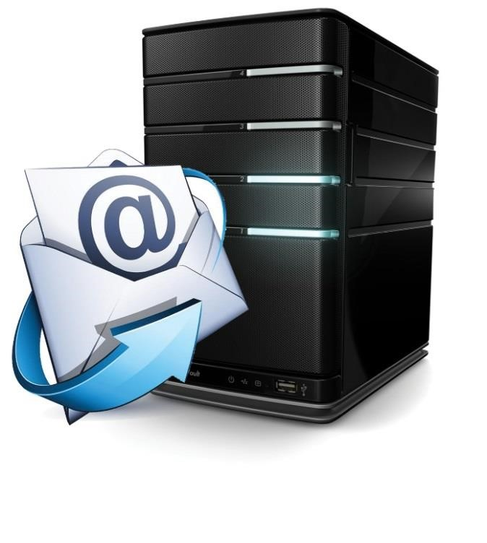

FTP SERVER

* File Transfer Protocol Server is a computer that provides file storage and access services on the Internet. They provide services in accordance with the FTP protocol. FTP, the file transfer protocol is a set of standard protocols for file transfer on the network, using the client/server model. FTP is a protocol specifically used to transfer files.
* FTP is a client/server system. Users use a client that supports the FTP protocol to connect to a server program on a remote host. The user issues a command on the client, and the remote host server executes the command issued by the user after receiving the command, and returns the execution result to the client.
* Simply put, the user sends a command to the server, asking the server to send a file to the user. The server responds and sends the file to the client. The user receives the file and places it in the user's working directory.
* This process is carried out by the FTP server.

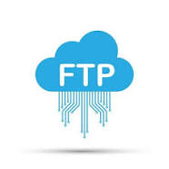

HTTP SERVER

* The Hypertext Transfer Protocol (HTTP) is an application-level protocol for distributed, collaborative, hypermedia information systems. This is the foundation for data communication for the World Wide Web (i.e. internet) since 1990. HTTP is a generic and stateless protocol which can be used for other purposes as well using extensions of its request methods, error codes, and headers.
* This tutorial is based on RFC-2616 specification, which defines the protocol referred to as HTTP/1.1. HTTP/1.1 is a revision of the original HTTP (HTTP/1.0). A major difference between HTTP/1.0 and HTTP/1.1 is that HTTP/1.0 uses a new connection for each request/response exchange, where as HTTP/1.1 connection may be used for one or more request/response exchanges.

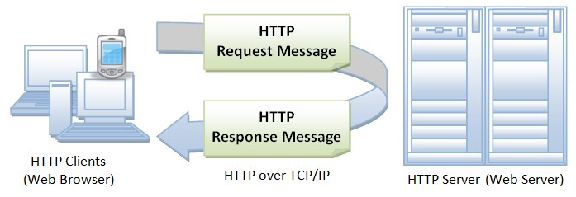

IP ADDRESS PLANING

|  |  |
| --- | --- |
| BLOCK A | |
| LAB 1 |  |
| LAB 2 |  |
| LAB 3 |  |

|  |  |
| --- | --- |
| BLOCK A DEPARTMENT | |
| CS 1 |  |

|  |  |
| --- | --- |
| BLOCK A SERVER ROOM | |
| BLOCK 1 |  |

|  |  |
| --- | --- |
| BLOCK B | |
| LAB 1 |  |
| LAB 2 |  |
| LAB 3 |  |

|  |  |
| --- | --- |
| BLOCK B DEPARTMENT | |
| ENGLISH DEPT |  |

|  |  |
| --- | --- |
| BLOCK C | |
| LAB 1 |  |
| LAB 2 |  |
| LAB 3 |  |

|  |  |
| --- | --- |
| BLOCK C DEPARTMENT | |
| ACCONTS DEPT |  |

|  |  |
| --- | --- |
| REGULAR BLOCK | |
| LAB 1 |  |
| LAB 2 |  |
| LAB 3 |  |

|  |  |
| --- | --- |
| REGULAR DEPARTMENT | |
| REGULAR DEPT |  |

|  |  |
| --- | --- |
| OFFICE BLOCK | |
| OFFICE 1 |  |

|  |  |
| --- | --- |
| NETCAFE BLOCK | |
| 1 |  |

ROUTER CODINGS

Router: Block A

Router> enable

Router# configuration terminal

router# interface gig 0/0/0

router# ip address 192.168.10.1 255.255.255.0

router# no shutdown

router# exit

Router# configuration terminal

router# interface gig 0/0/1

router# ip address 192.168.12.1 255.255.255.0

router# no shutdown

router# exit

Router# configuration terminal

router# interface se 0/1/0

router# ip address 10.0.0.2 255.0.0.0

router# no shutdown

router# exit

Router# configuration terminal

router# interface se 0/1/1

router# ip address 15.0.0.1 255.0.0.0

router# no shutdown

router# exit

Router: Block B

Router> enable

Router# configuration terminal

router# interface gig 0/0/0

router# ip address 192.168.14.1 255.255.255.0

router# no shutdown

router# exit

Router# configuration terminal

router# interface gig 0/0/1

router# ip address 192.168.15.1 255.255.255.0

router# no shutdown

router# exit

Router# configuration terminal

router# interface se 0/1/0

router# ip address 11.0.0.2 255.0.0.0

router# no shutdown

router# exit

Router# configuration terminal

router# interface se 0/2/1

router# ip address 16.0.0.1 255.0.0.0

router# no shutdown

router# exit

Router: Block C

Router> enable

Router# configuration terminal

router# interface gig 0/0/0

router# ip address 192.168.19.1 255.255.255.0

router# no shutdown

router# exit

Router# configuration terminal

router# interface gig 0/0/1

router# ip address 192.168.20.1 255.255.255.0

router# no shutdown

router# exit

Router# configuration terminal

router# interface gig 0/0/2

router# ip address 192.168.18.1 255.255.255.0

router# no shutdown

router# exit

Router# configuration terminal

router# interface se 0/1/0

router# ip address 12.0.0.2 255.0.0.0

router# no shutdown

router# exit

Router: Office Block_Self

Router> enable

Router# configuration terminal

router# interface gig 0/0/0

router# ip address 192.168.19.1 255.255.255.0

router# no shutdown

router# exit

Router# configuration terminal

router# interface se 0/1/0

router# ip address 13.0.0.2 255.0.0.0

router# no shutdown

router# exit

Router# configuration terminal

router# interface se 0/1/1

router# ip address 20.0.0.1 255.0.0.0

router# no shutdown

router# exit

Router: Regular Block

Router> enable

Router# configuration terminal

router# interface gig 0/0/0

router# ip address 192.168.25.1 255.255.255.0

router# no shutdown

router# exit

Router# configuration terminal

router# interface gig 0/0/1

router# ip address 192.168.26.1 255.255.255.0

router# no shutdown

router# exit

Router# configuration terminal

router# interface se 0/1/0

router# ip address 14.0.0.2 255.0.0.0

router# no shutdown

router# exit

Router: COE

Router> enable

Router# configuration terminal

router# interface gig 0/0/0

router# ip address 30.0.0.1 255.0.0.0

router# no shutdown

router# exit

Router# configuration terminal

router# interface gig 0/0/0

router# ip address 192.168.21.1 255.255.255.0

router# no shutdown

router# exit

FLOW DIAGRAM OF DHCP SERVER

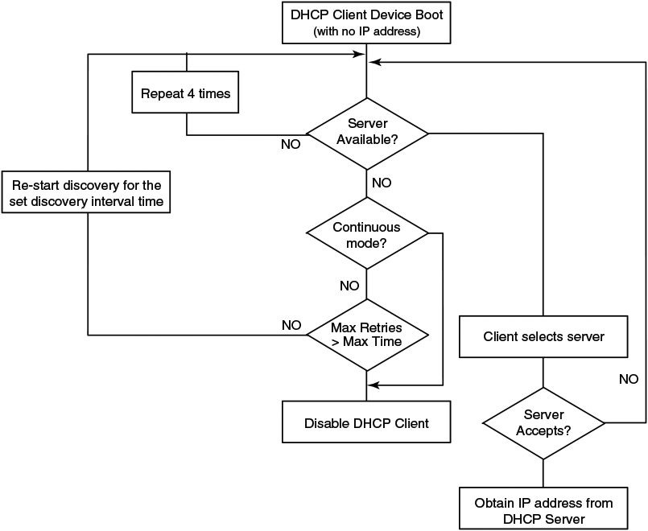

FLOW DIAGRAM OF FTP SERVER

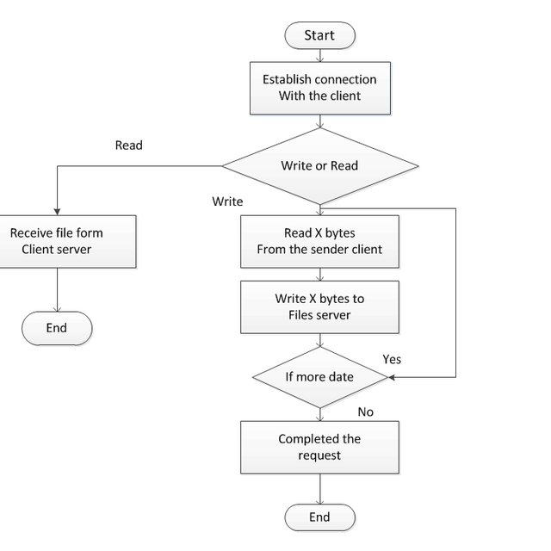

FLOW DIAGRAM OF IOT DEVICES

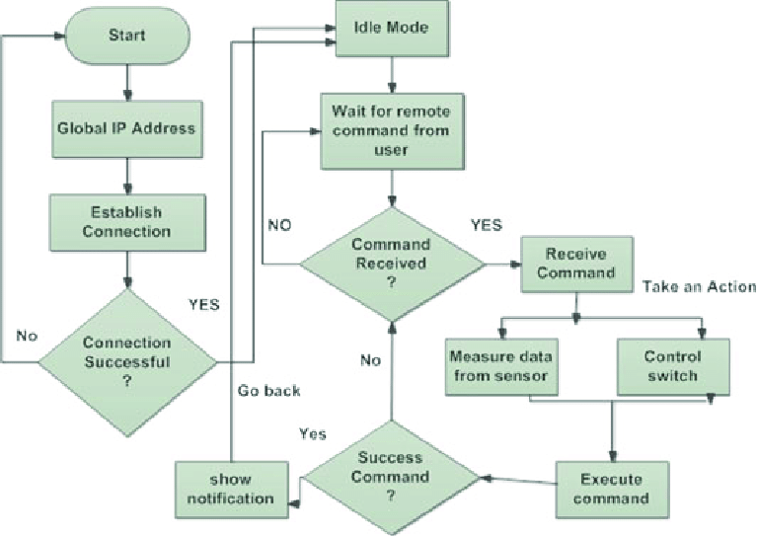

SCREENSHOTS

TOPOLOGY

OVERALL DESIGN

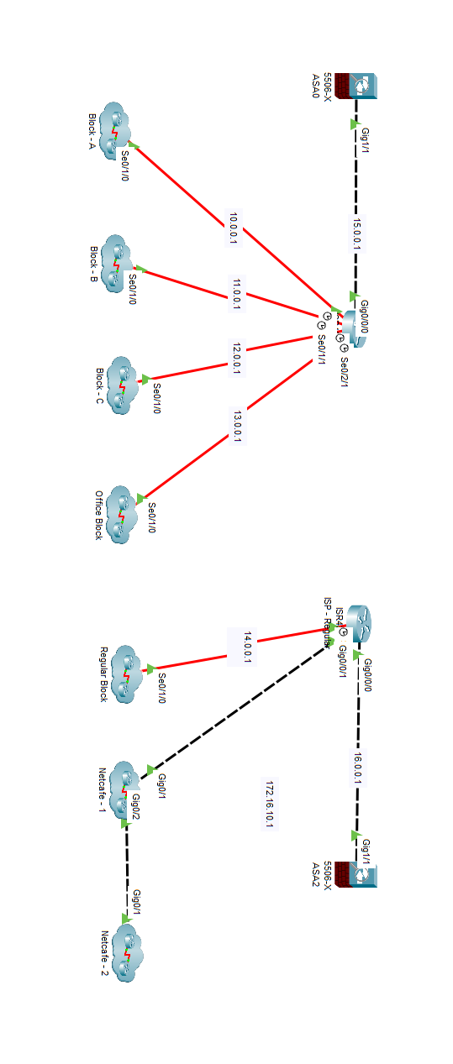

BLOCK A

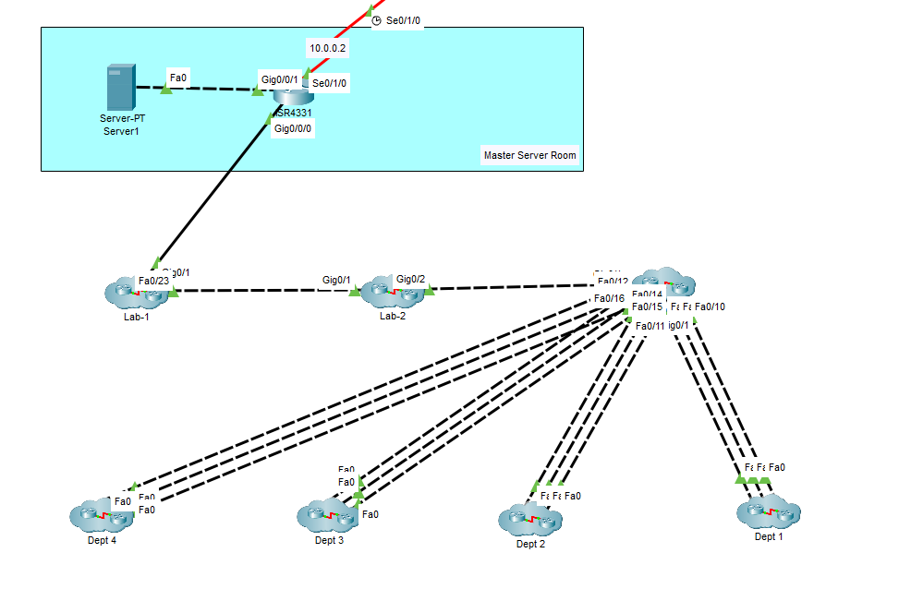

BLOCK A – LAB 1

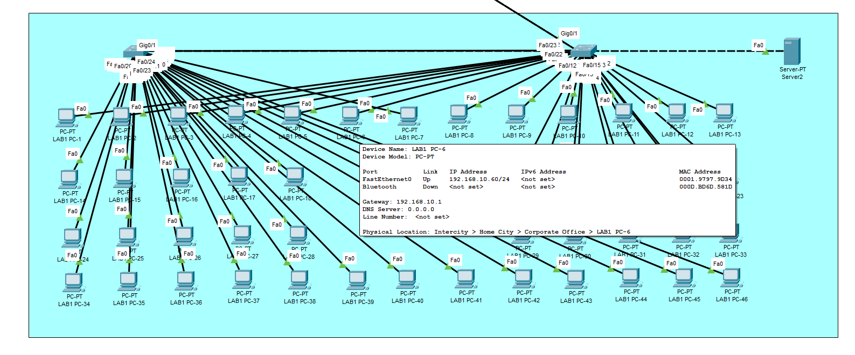

BLOCK A – LAB 2

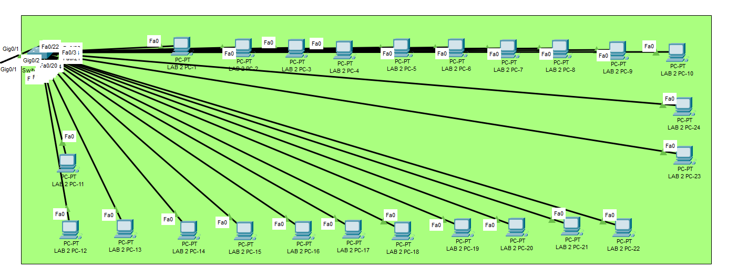

BLOCK A – LAB 3

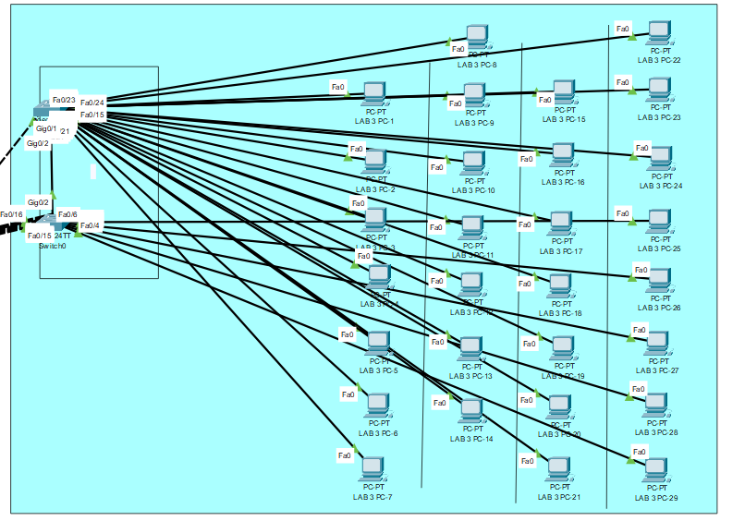

BLOCK A – DEPARTMENT

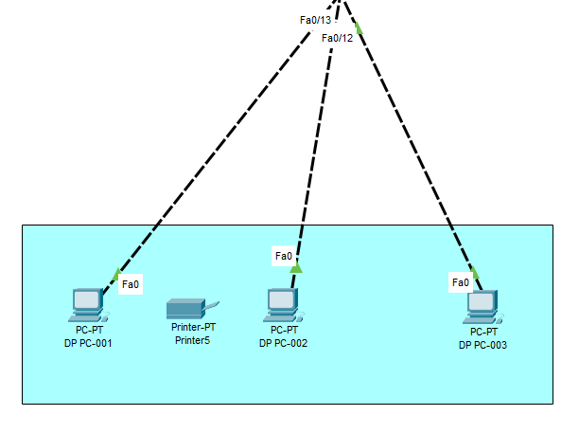

BLOCK B

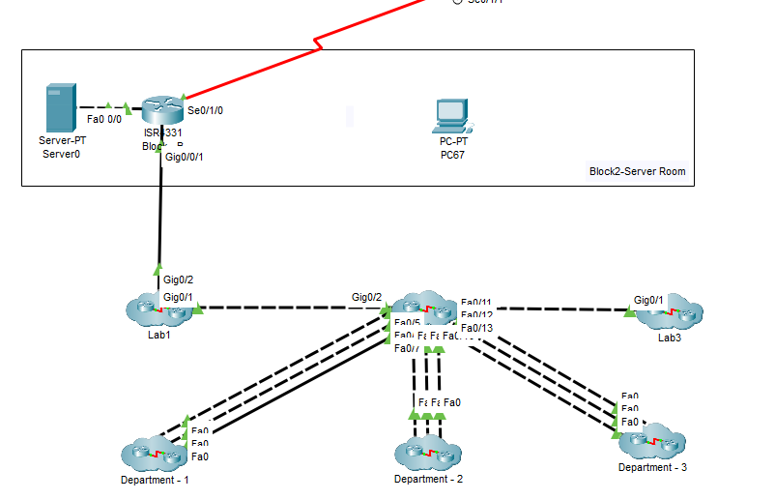

BLOCK B – LAB 1

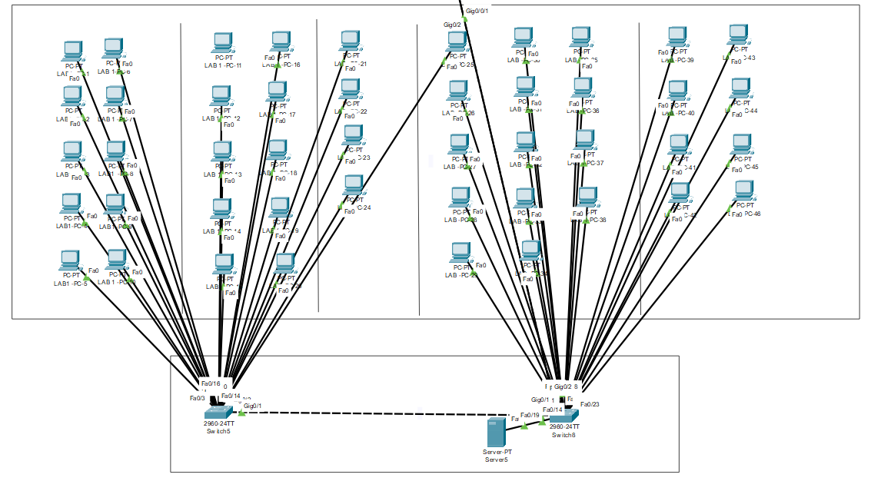

BLOCK B – LAB 2

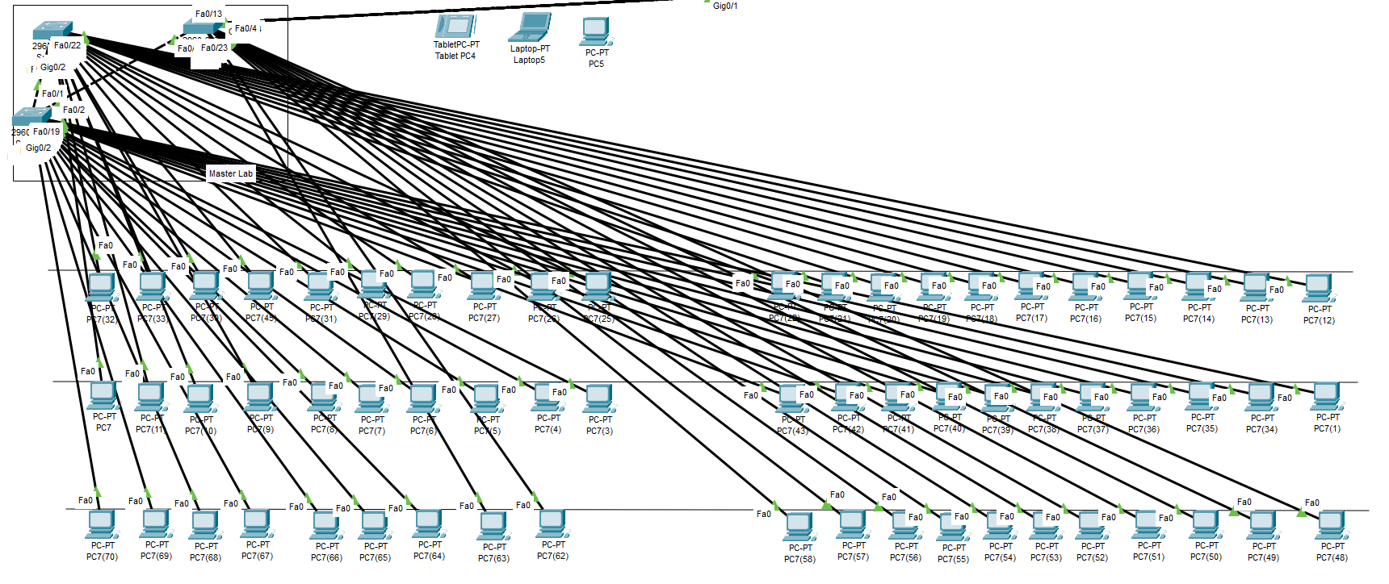

BLOCK B – LAB 3

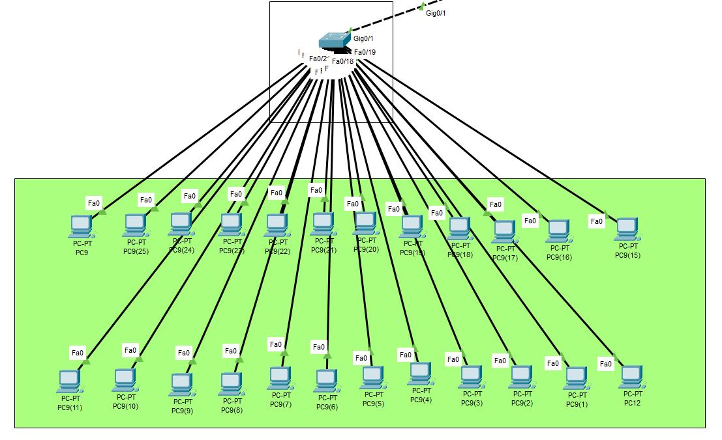

BLOCK B – DEPARTMENT

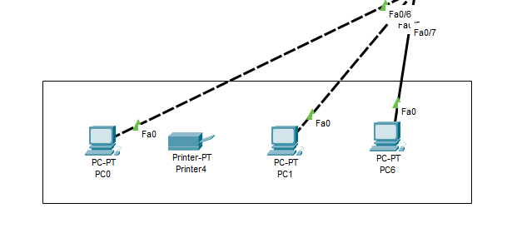

BLOCK C

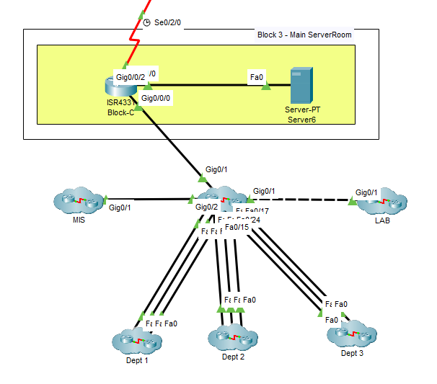

BLOCK C – LAB 1

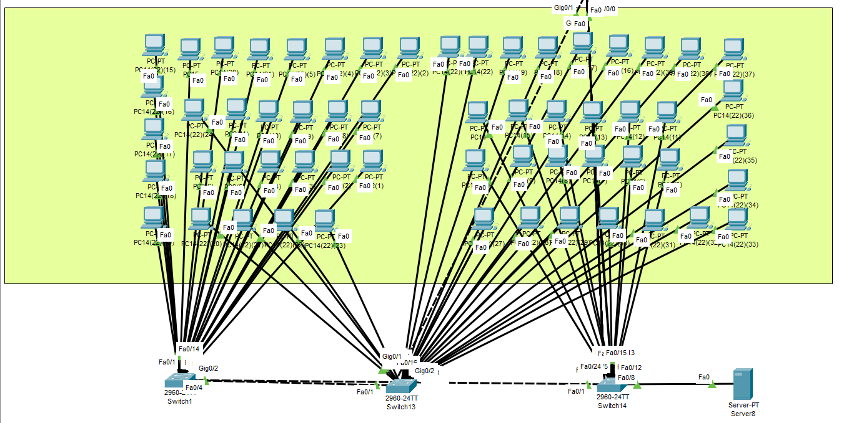

BLOCK C – LAB 2

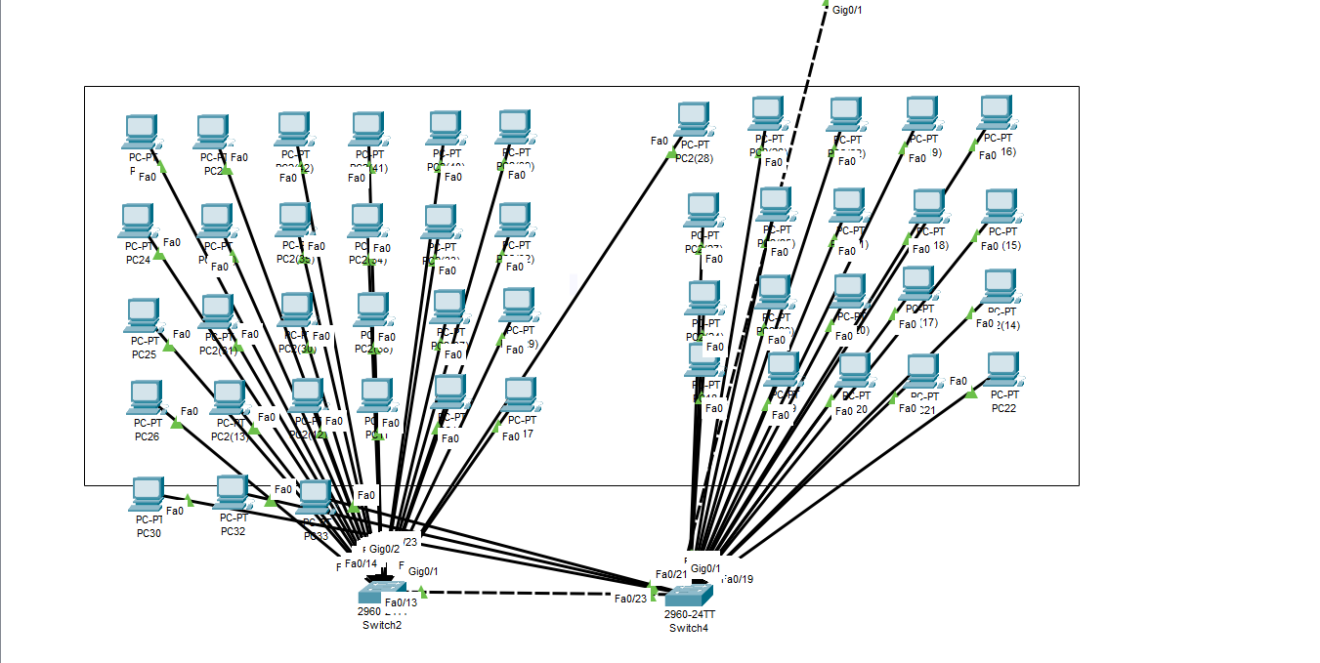

BLOCK C – DEPARTMENT

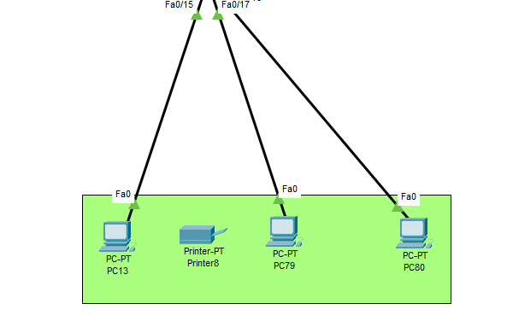

OFFICE BLOCK

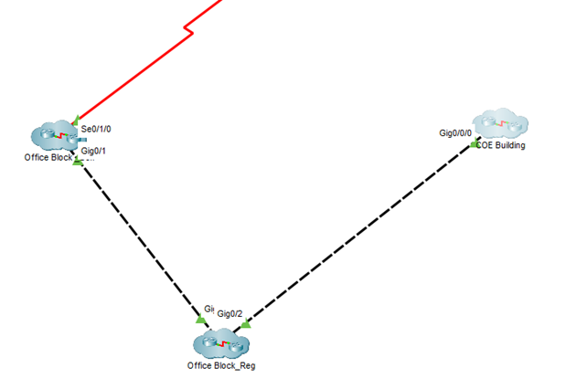

OFFICE SELF

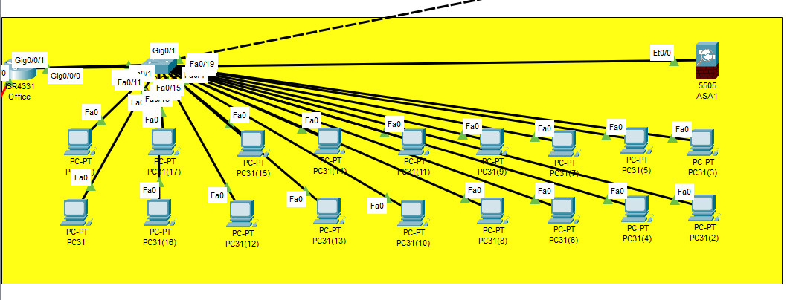

OFFICE REGULAR

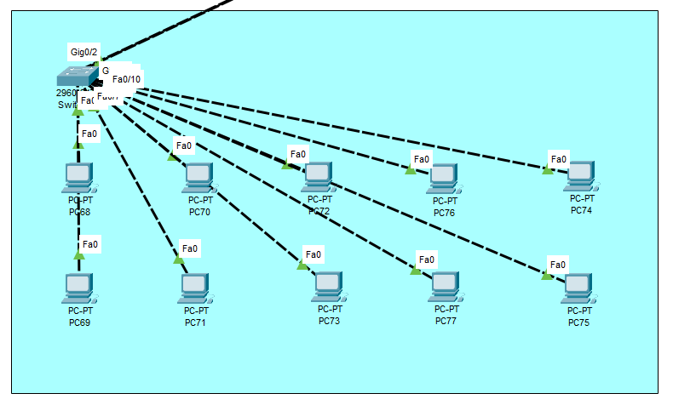

COE

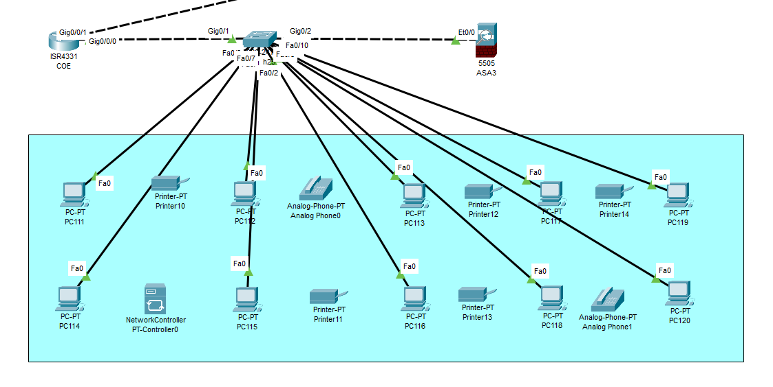

REGULAR BLOCK

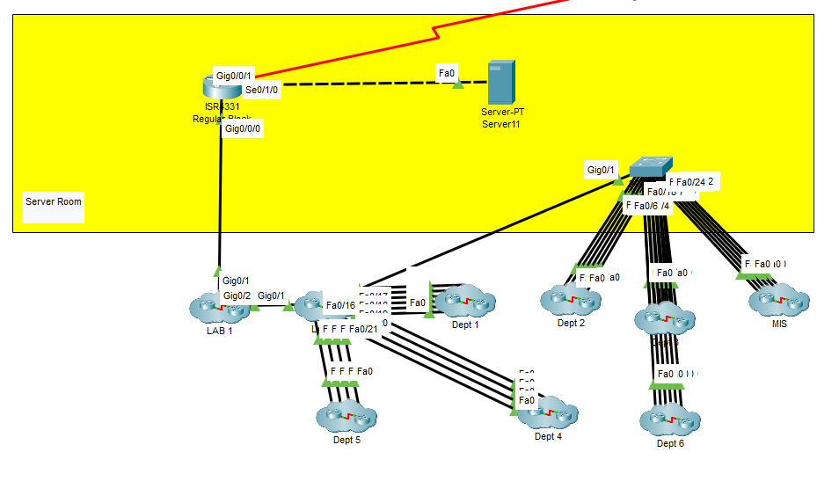

REGULAR BLOCK LAB-1

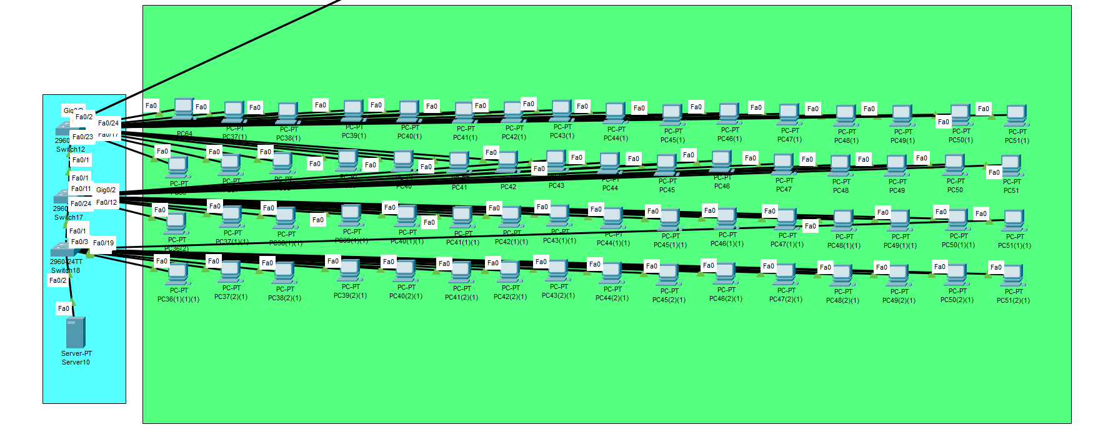

REGULAR BLOCK LAB-2

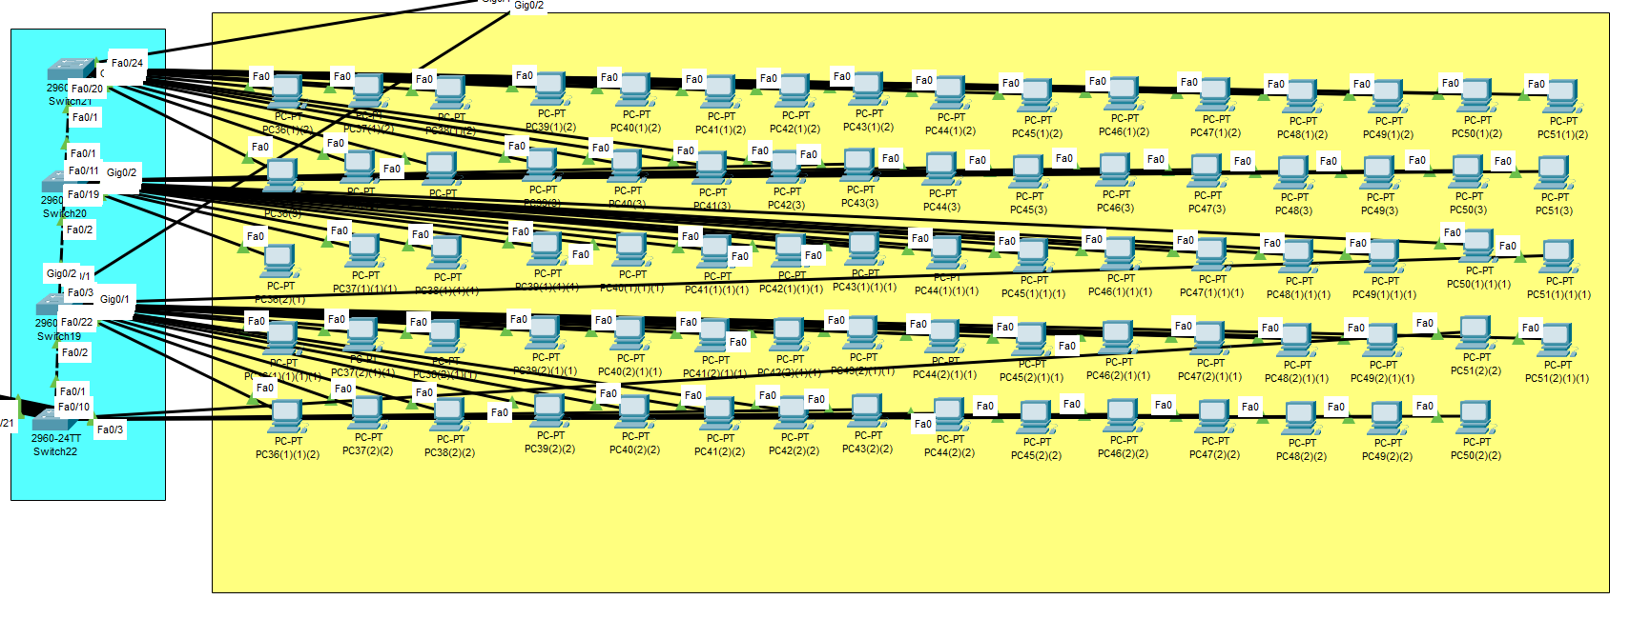

REGULAR BLOCK DEPARTMENT- 1

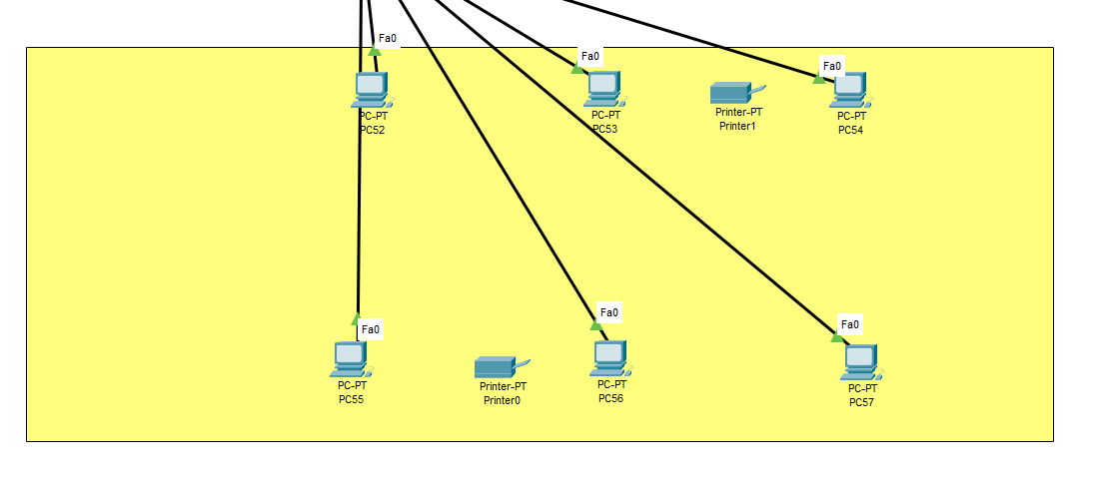

REGULAR BLOCK DEPARTMENT -2

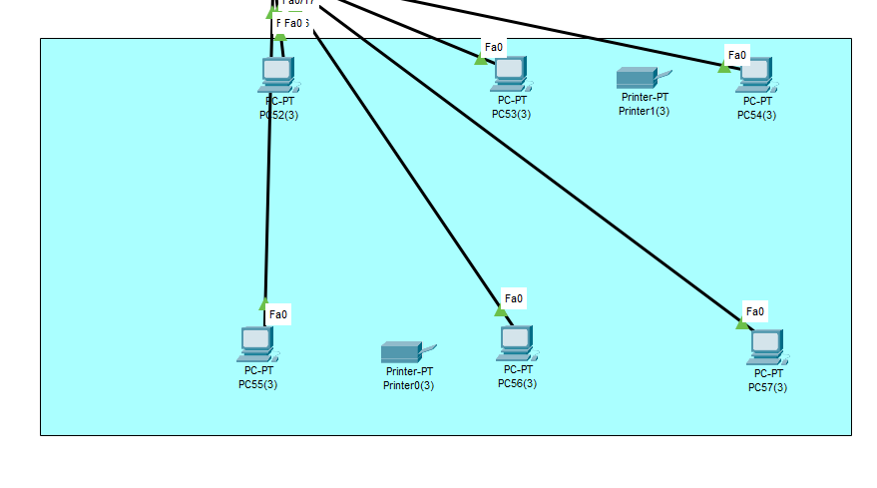

MIS BLOCK REGULAR

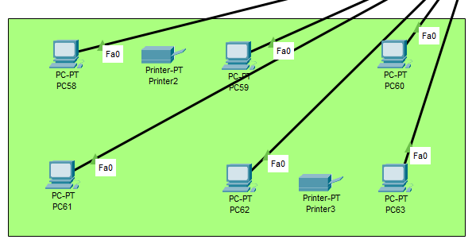

NETCAFE – 1

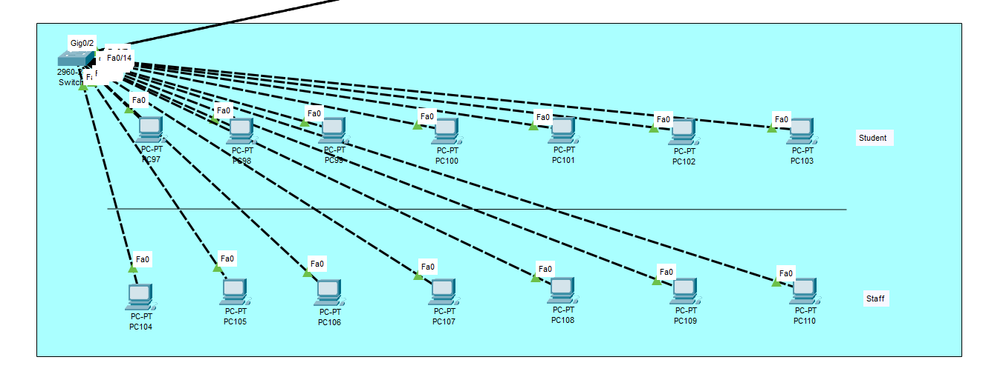

NETCAFE – 2

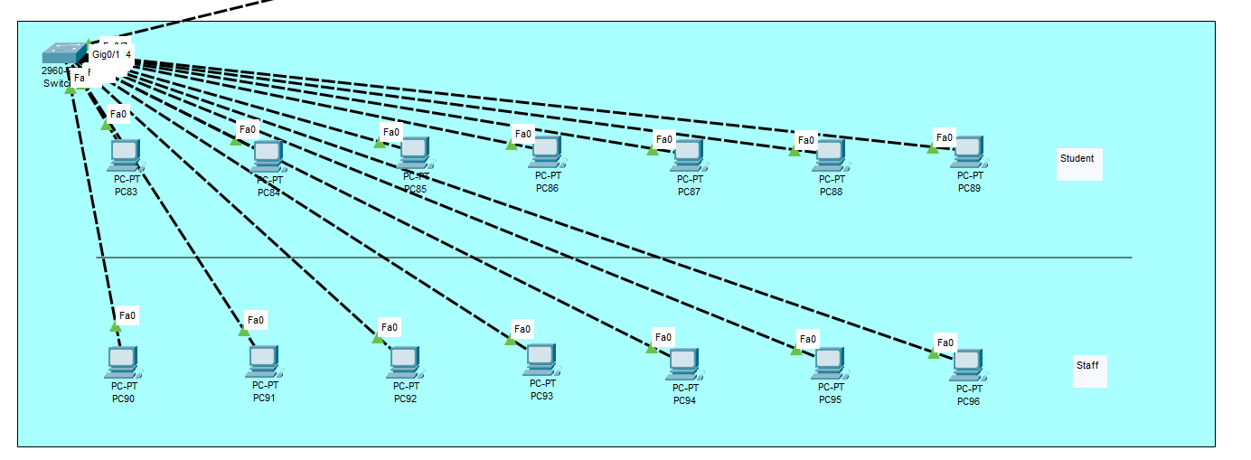

IOT DEVICES

BLOCK A

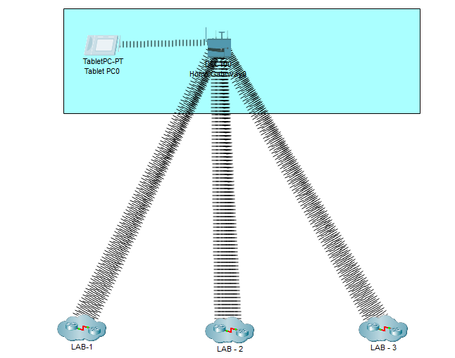

BLOCK A LAB – 1 IoT

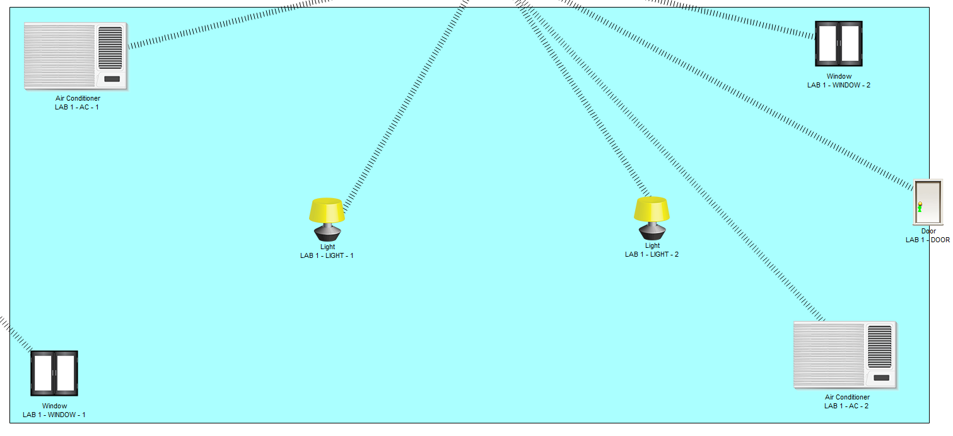

BLOCK A LAB–2 –IoT

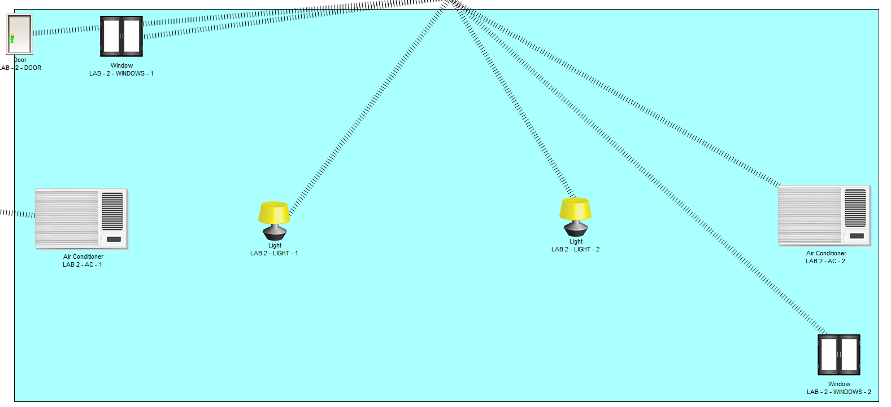

BLOCK A LAB– 3–IoT

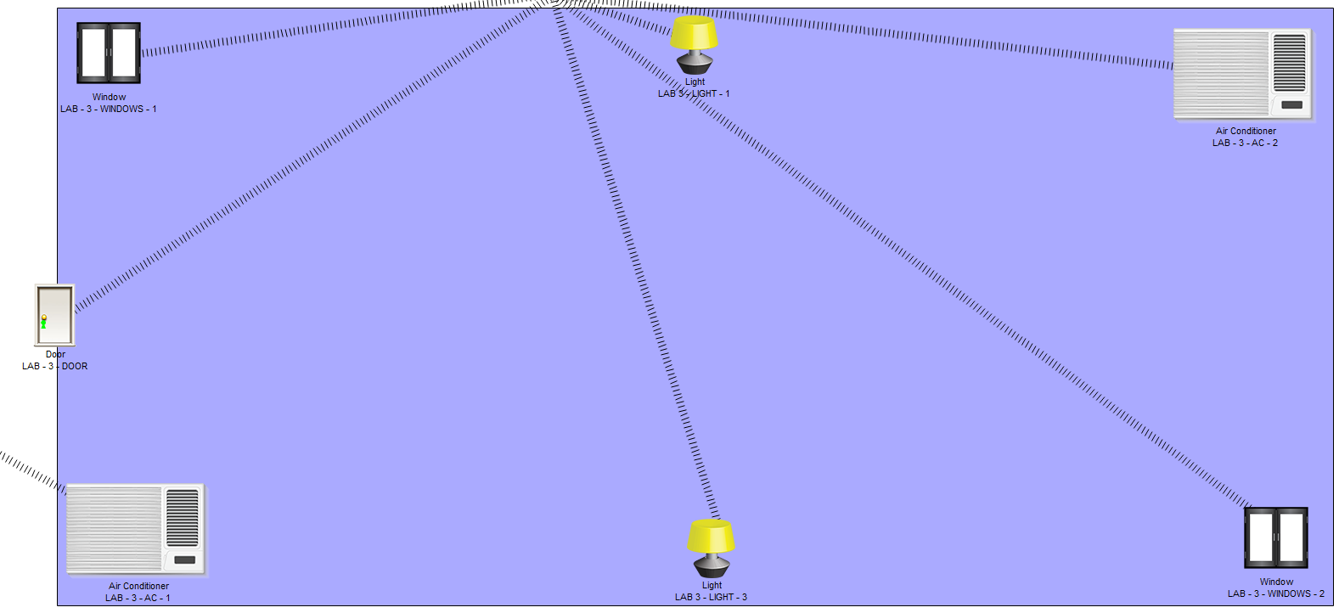

BLOCK B IOT

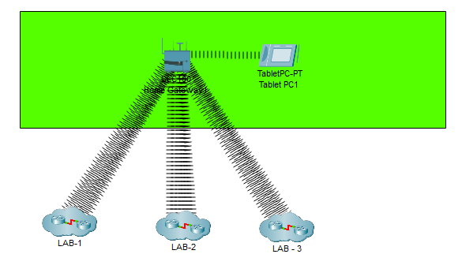

BLOCK B LAB– 1–IoT

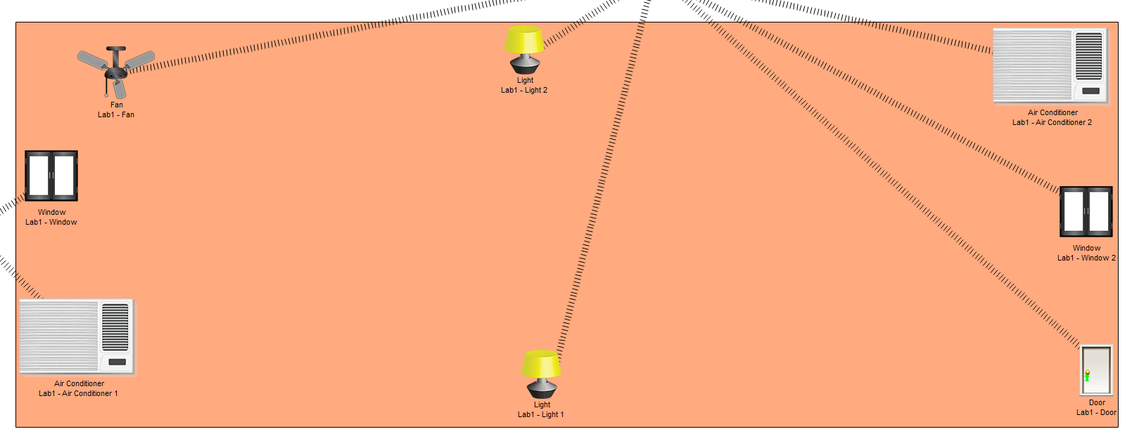

BLOCK B LAB– 2–IoT

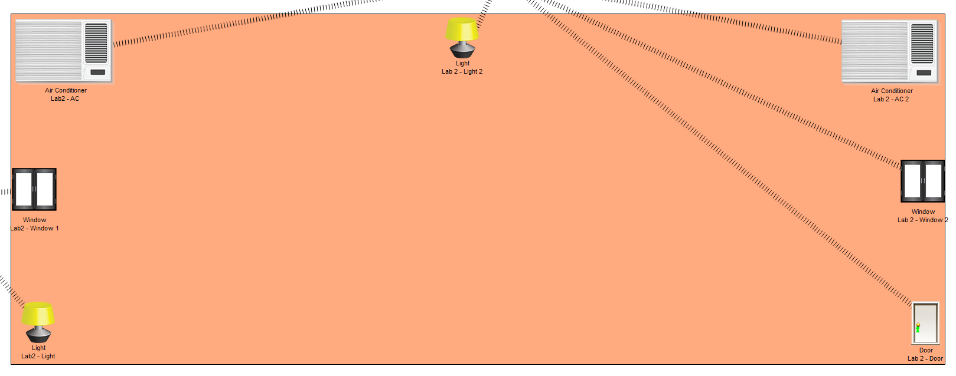

BLOCK B LAB– 3–IoT

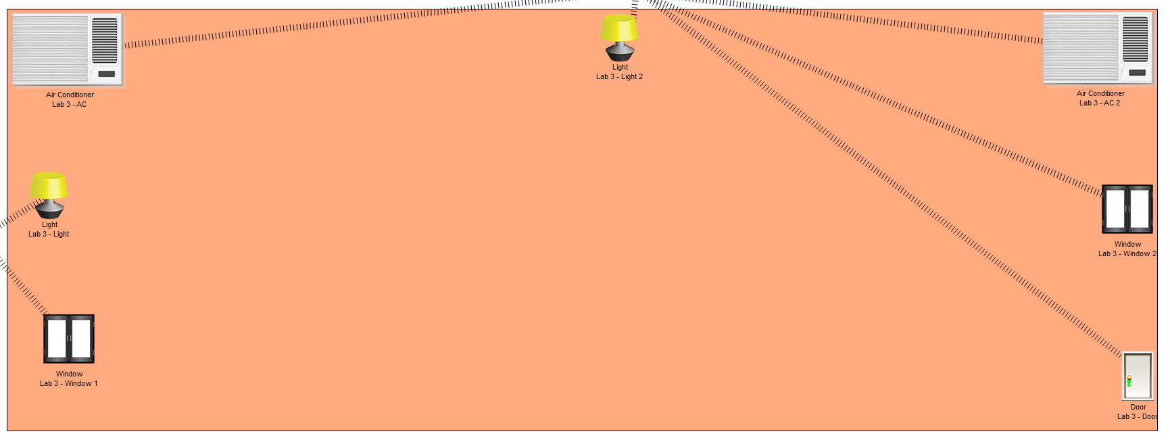

BLOCK B LAB– 3–IoT



BLOCK C IOT

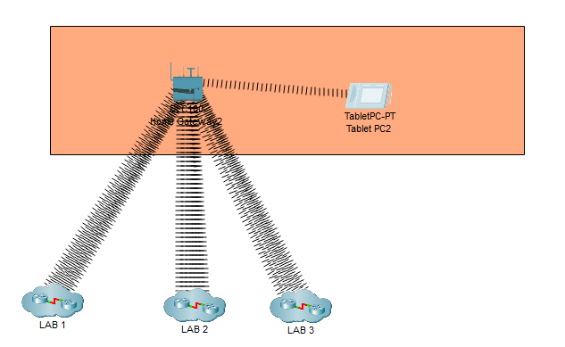

BLOCK C LAB-1 IOT

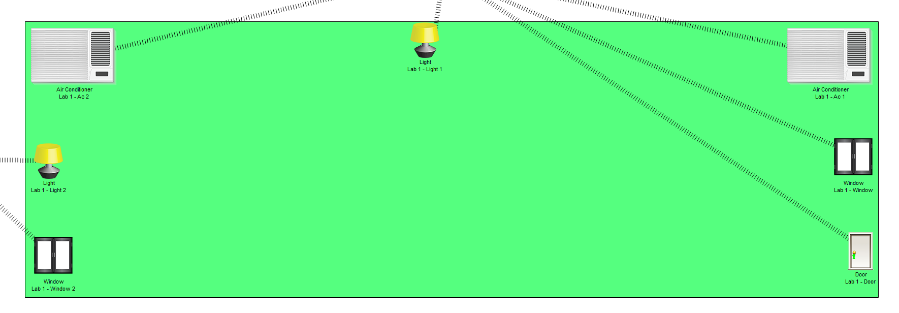

BLOCK C LAB-2 IOT

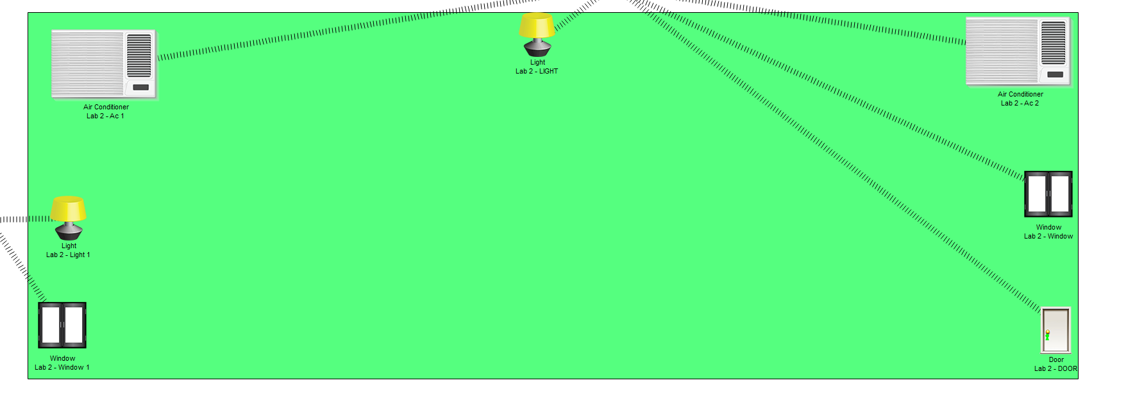

BLOCK C LAB-3 IOT

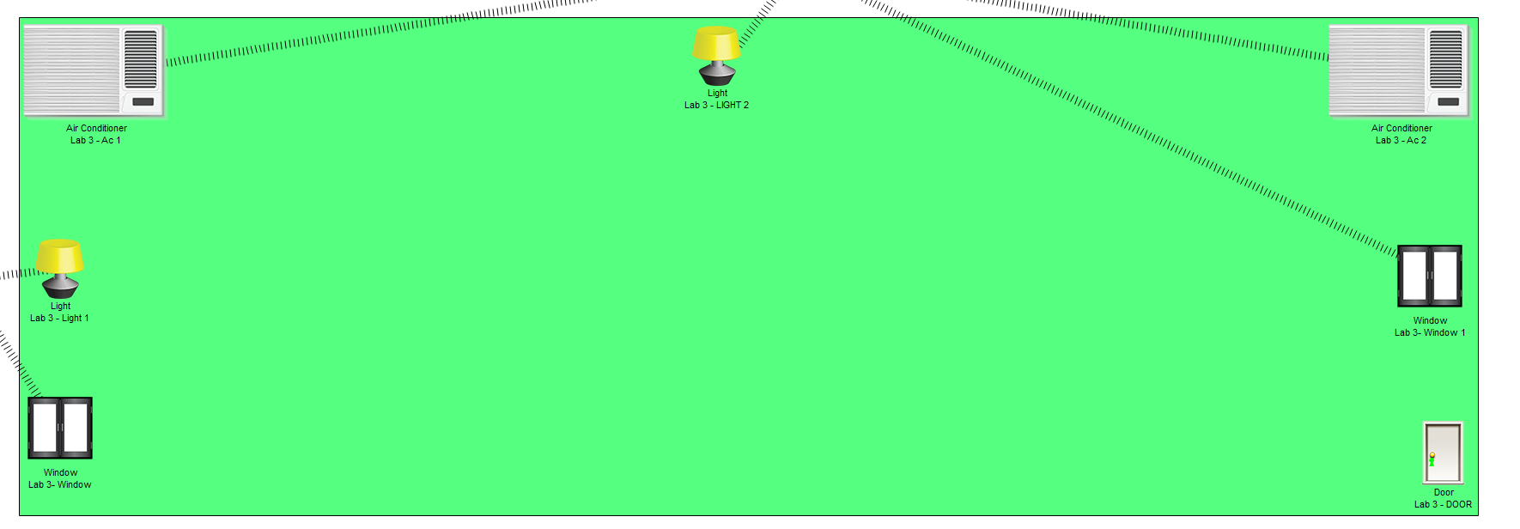

REGULAR BLOCK IOT

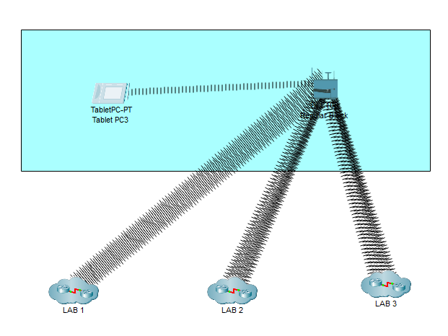

REGULAR BLOCK LAB-1 IOT

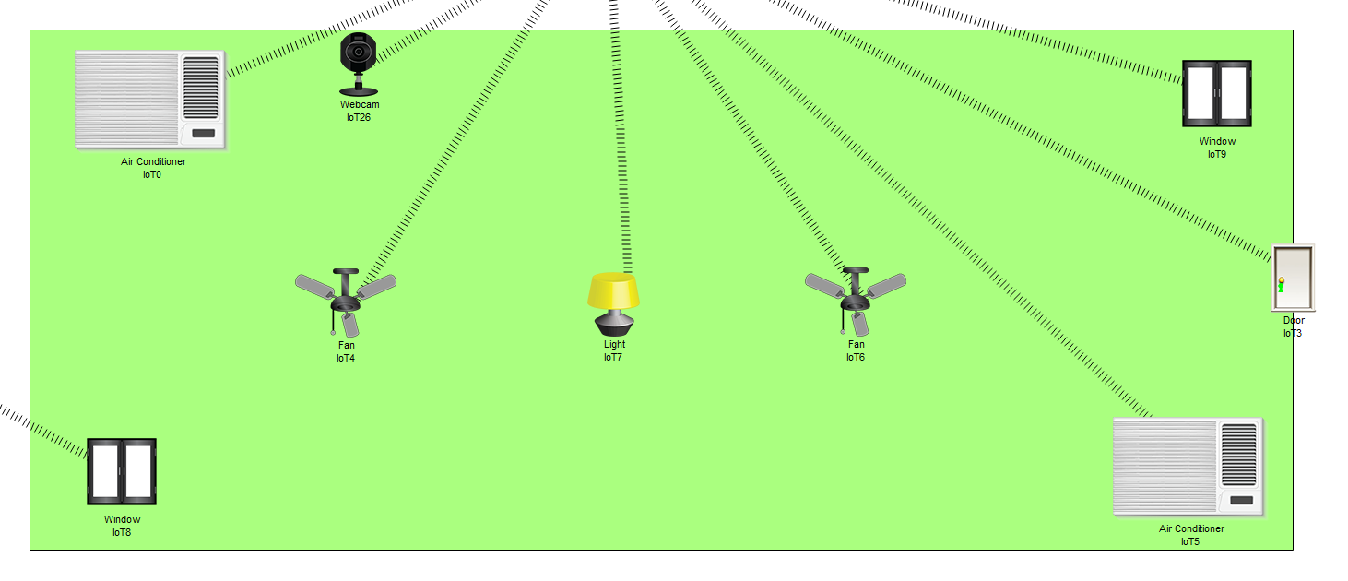

REGULAR BLOCK LAB-2 IOT

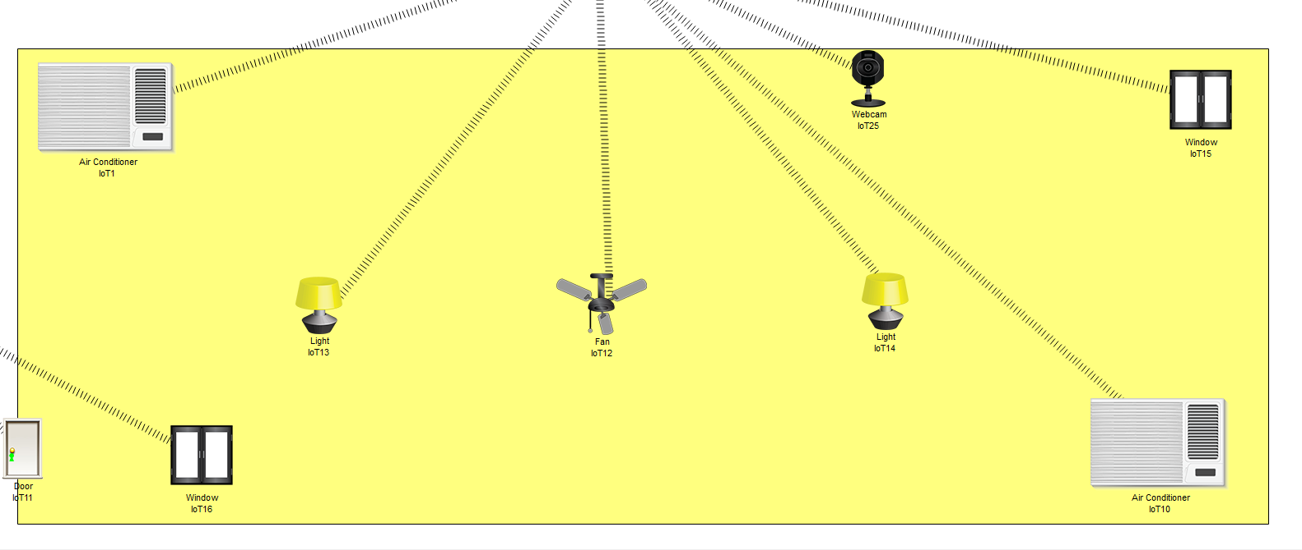

REGULAR BLOCK LAB-3 IOT

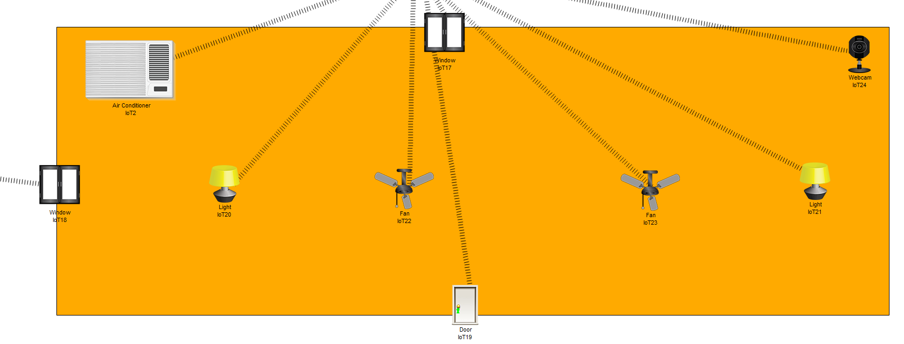

7. FUTURE ENHANCEMENT

The project feature can be further enhanced with all authentication and logon information by encrypting the data when transmitted over user and the web site. In addition, it is possible to configure windows7 server networking for further firewall security so that all data that passes between a client and server is secured properly. Enhancing various element, which are not required for the current set of process, can further develop the project.

8. CONCLUSION

This “Designing a Network Infrastructure for a College Campus” has been developed successfully incorporating all the requirements. It provides security to the member’s personal information by giving a user id. This site has further enhancement facility to use the Infrastructure.

After the system has been implemented, the maintenances of the system should be very easy so that the forthcoming changes can be made easily. This has been developed is so flexible that the change can be made easily.

The quality factors like correctness, efficiency, usability, Maintainability portability, accuracy, error tolerance, expandability are insisted and tested successfully.

1. BIBLIOGRAPHY
2. Books referred:
3. CONFIGURATION AND IMPLEMENTATION

The Complete Reference by SANSBOUND CCNA Book by Keti Reddy.

1. CCNA PREPARATION LIBRARY (640-801)

[CCNA exam preparation book](https://www.ciscopress.com/store/ccna-self-study-ccna-preparation-library-640-801-9781587051845) is authorized by Cisco

1. CISCO CERTIFIED NETWORK ASSOCIATE STUDY GUIDE (640-802)

Cisco Certified Network Associate Study Guide authored by Todd Lammle

1. Websites:

[www.IoT4beginners.com](http://www.IoT4beginners.com)

www.GeeksforGeek.org

[www.microsoft.com](http://www.microsoft.com)